Imagine yourself as a celebrity chef, not just whipping up impressive dishes but revolutionizing the culinary world. That's the realm of advanced coding. You've mastered the core programming techniques and are now ready to specialize. Dive deep into areas like system programming, crafting the very foundation of software. Perhaps machine learning sparks your interest, where you'll build intelligent systems that can learn and adapt. The possibilities are vast, allowing you to become a true expert in your chosen domain.

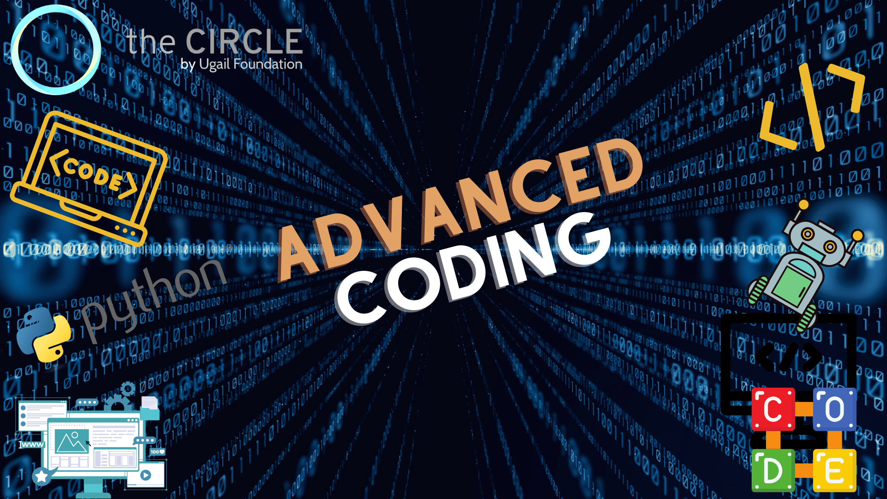

Advanced coding isn't just about technical prowess; it's about problem-solving on steroids. You'll become a master architect, dissecting complex challenges and designing creative solutions. Thinking laterally and coming up with innovative approaches becomes second nature. You might even contribute to open-source projects, collaborating with a global community of developers to create groundbreaking software. Communication becomes paramount as you bridge the gap between technical aspects and project goals, potentially leading to a technical leadership role.

The journey to becoming an advanced coder is a marathon, not a sprint. It requires dedication, a love for learning, and the constant pursuit of knowledge. But the rewards are incredible. You'll be tackling the most challenging problems, crafting revolutionary software systems, and potentially shaping the future of technology.